INFOSYS SPRINGBOARD VIRTUAL INTERNSHIP

Module 5: Revenue Strategy Dashboard

Name: Shiven Pratap Singh

Project Name: HotelRevAI AI Driven Revenue Analysis for Hotels_Batch -13

Introduction

Module 5 is centred on building a detailed Revenue Strategy Dashboard that helps both General Managers and Revenue Managers make smarter, data-driven decisions related to pricing and revenue optimization. It combines insights from ancillary revenue, upselling performance, and dynamic pricing to evaluate earnings from both room bookings and additional services.

Using tools like Power BI, Power Query, DAX, and What-If parameters, this module allows users to interact with different scenarios by adjusting pricing, demand sensitivity, and occupancy levels. This interactive approach provides meaningful insights that support better revenue planning, improve RevPAR, and enhance overall customer value.

Data Preparation and Ancillary Revenue Table Creation
To analyze revenue beyond room bookings, an Ancillary Transactions table was created using Power Query. To analyze non-room revenue and evaluate upsell opportunities, an Ancillary Transactions table was created using Power Query (M language). This table simulates realistic ancillary services such as Spa, Dining, and Other Services availed by guests during their stay.
The logic begins by filtering valid bookings and then programmatically generating service details, quantities, transaction dates, and revenue amounts to closely reflect real-world hotel operations.
Key Columns in Ancillary Transactions Table
- TransID – Unique identifier for each ancillary transaction
- BookingID – Links ancillary revenue to room bookings
- CustomerID – Identifies the guest
- Date – Date on which the service was availed
- ServiceType – Category of service (Spa, Dining, Services)
- Item – Specific service offered
- Quantity – Number of services used
- Amount – Revenue generated from the service
This table forms the foundation for analyzing upsell behavior and non-room revenue contribution.

Power Query Formula Used
let
// Load Bookings table Source = Bookings,

// Filter valid bookings ValidBookings = Table.SelectRows(
Source,
each [CheckInDate] <> null and [CheckOutDate] <> null
),

// Add ServiceType randomly WithServiceType = Table.AddColumn(
ValidBookings, "ServiceType", each
let r = Number.Mod(Text.Length([BookingID]), 3) in if r = 0 then "Spa"
else if r = 1 then "Dining" else "Services"
),

// Add Item based on ServiceType WithItem = Table.AddColumn(
WithServiceType, "Item",
each
if [ServiceType] = "Spa" then "Swedish Massage" else if [ServiceType] = "Dining" then "Buffet Dinner" else "Airport Pickup"
),

// Add Quantity randomly (1 to 3) WithQuantity = Table.AddColumn(
WithItem, "Quantity", each

1 + Number.Mod( Text.Length([CustomerID]) + Number.From(Date.Day([CheckInDate])), 3
)
),

// Add Amount based on ServiceType and Quantity WithAmount = Table.AddColumn(
WithQuantity, "Amount", each
let base =
if [ServiceType] = "Spa" then 1800
else if [ServiceType] = "Dining" then 1200 else 1000
in base * [Quantity]
),

// Add Transaction Date within stay period WithDate = Table.AddColumn(
WithAmount, "Date",
each
let
los = Duration.Days([CheckOutDate] - [CheckInDate]), offset =
Number.Mod( Text.Length([RoomTypeID]) +
Number.From(Date.Day([CheckOutDate])), los + 1
)

in Date.AddDays([CheckInDate], offset)
),

// Add TransID
WithIndex = Table.AddIndexColumn( WithDate,
"TransID", 1,
1,
Int64.Type
),

Final = Table.TransformColumns( WithIndex,
{{"TransID", each "ANC" & Text.PadStart(Text.From(_), 5, "0"), type text}}
),

// Select final columns
AncillaryTable = Table.SelectColumns( Final,
{"TransID", "BookingID", "CustomerID", "Date", "ServiceType", "Item", "Quantity", "Amount"}
)
in
AncillaryTable

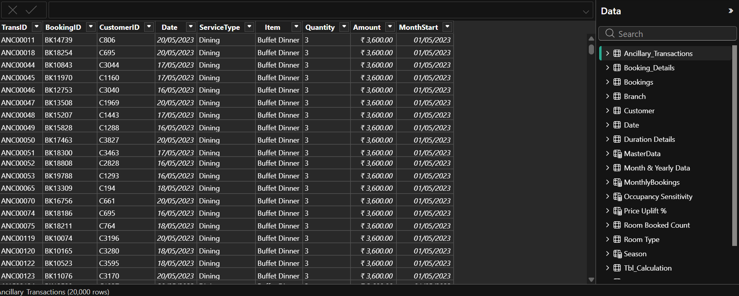

Measures Used for Revenue Analysis
- Ancillary Revenue
This measure calculates the total revenue generated from ancillary services.

Ancillary Revenue = SUM(Ancillary_Transactions[Amount])
It helps assess the overall contribution of Spa, Dining, and Services to total hotel revenue.

Ancillary Revenue per Booking
This measure calculates the average ancillary revenue generated per booking.

Ancillary Rev / Booking = DIVIDE(
SUM(Ancillary_Transactions[Amount]), COUNT(Booking[BookingID])
)
It evaluates the effectiveness of upselling strategies across bookings.

Upsell Conversion Percentage
This measure calculates the percentage of bookings that resulted in at least one ancillary service purchase.

Upsell Conversion % = DIVIDE(
DISTINCTCOUNT(Ancillary_Transactions[BookingID]), DISTINCTCOUNT(Booking[BookingID])
)
It reflects how successfully room bookings are converted into additional revenue opportunities.

Pricing Strategy Using What-If Parameters

To enable interactive revenue planning, What-If parameters were implemented.

Price Uplift %
This parameter allows users to simulate promotional discounts or strategic price increases by adjusting room prices dynamically. It supports scenario testing without modifying core DAX calculations.

Occupancy Sensitivity Value
This parameter represents price elasticity with respect to occupancy. Higher values indicate aggressive pricing during high demand, while lower values indicate conservative pricing to protect occupancy.
These parameters allow decision-makers to explore different revenue strategies interactively.

Recommended Price (Dynamic Pricing Logic)
A Recommended Price measure was created to calculate an optimized room rate by combining historical pricing, seasonality, promotional uplift, and occupancy sensitivity.

Recommended Price = VAR BaseADR = [DADR]
VAR SeasonAdj = SWITCH(
SELECTEDVALUE('Date'[Season]), "High", 0.15,
"Shoulder", 0.05,

"Low", -0.10,
0
)
VAR Uplift = [Price Uplift % Value]
VAR Elasticity = [Occupancy Sensitivity Value] RETURN
BaseADR * (1 + SeasonAdj + Uplift) * Elasticity
This measure helps recommend optimal prices under varying demand and market conditions.

Visualization & Analysis (Output)
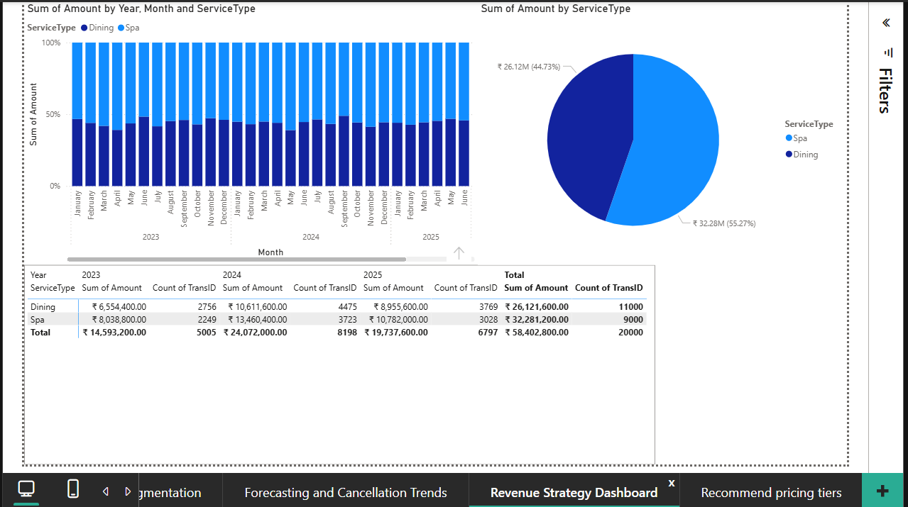

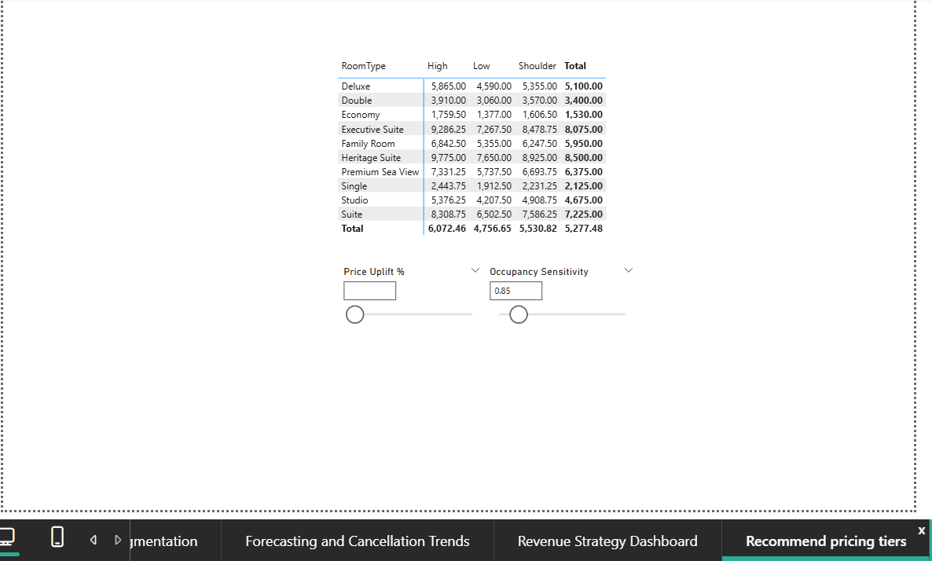

- A stacked column chart shows ancillary revenue trends by service type (Dining, Spa, Services) across months and years. Dining and Spa contribute the highest share of non-room revenue, with visible seasonal peaks.
- A monthly table highlights service-wise revenue and transaction counts, helping identify high- volume and high-value ancillary services. Dining shows frequent usage, while Spa generates higher revenue per transaction.
- A pie chart displays the percentage contribution of each service type to total ancillary revenue, clearly indicating the dominance of Dining and Spa services.
- A Pricing Tier Recommendations matrix presents dynamically calculated recommended prices by room type and season, enabling easy comparison across demand periods.
- What-If sliders (Price Uplift % and Occupancy Sensitivity) allow scenario simulation, showing how pricing changes impact recommended room rates.
Overall, these visuals support data-driven revenue optimization, combining ancillary performance insights with dynamic pricing strategy.

Insights and Learning from Module 5
- Ancillary services contribute significantly to total revenue, highlighting strong upsell potential.
- Upsell conversion varies across customer segments, indicating opportunities for targeted promotions.
- Dynamic pricing enables flexible price optimization based on seasonality and demand sensitivity.
- Scenario analysis helps balance higher ADR with potential occupancy impact.
- Integrating ancillary revenue with pricing strategy improves overall RevPAR optimization.

Conclusion
Module 5 successfully integrates ancillary revenue analysis with dynamic pricing strategies to create a powerful Revenue Strategy Dashboard. By combining DAX measures, Power Query transformations, and What-If parameters, the dashboard enables interactive, scenario-driven decision-making.
This module equips hotel management with actionable insights to optimize pricing, enhance upselling performance, and maximize overall revenue in a competitive hospitality environment.

Dashboard

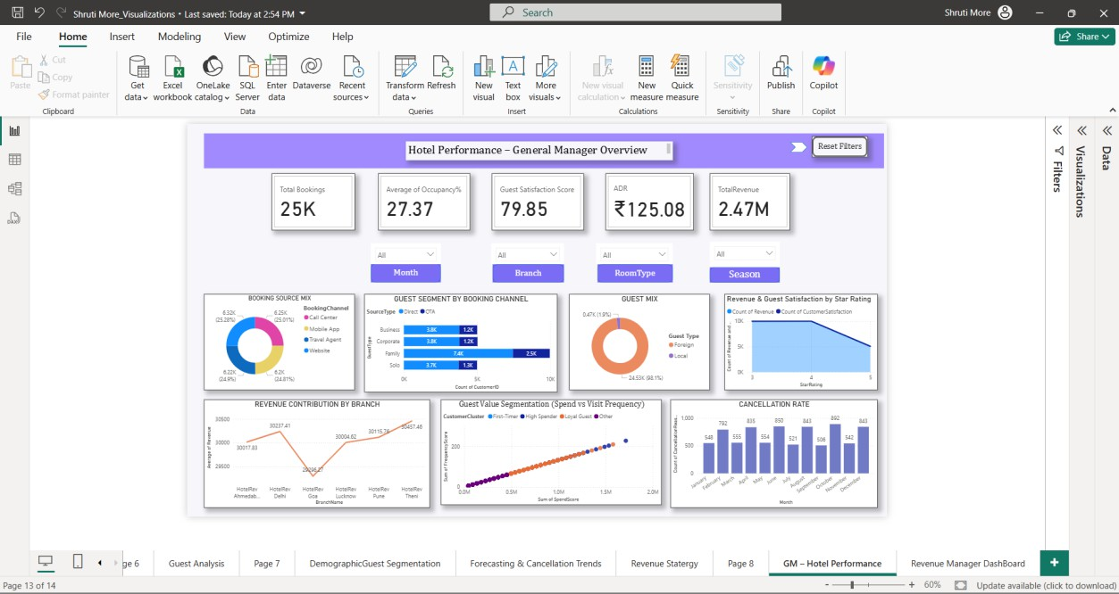

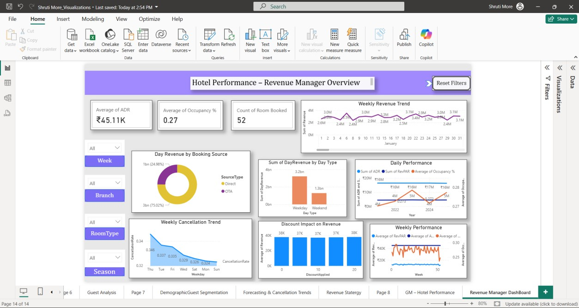

- General Manager Dashboard
The General Manager Overview provides a high-level snapshot of overall hotel performance.
  - KPI cards display Total Bookings, Average Occupancy %, Guest Satisfaction Score, ADR, and Total Revenue
  - Visuals show revenue contribution by branch, guest mix, booking channel distribution, and customer value segmentation
  - Cancellation rate and guest satisfaction trends help evaluate service quality and booking reliability This dashboard enables senior management to quickly assess business health and performance trends.

- Revenue Manager Dashboard
The Revenue Manager Overview focuses on detailed, time-based revenue optimization.
  - KPI cards highlight Average ADR, Occupancy %, and Rooms Booked
  - Weekly revenue and cancellation trends help monitor short-term performance
  - Visuals such as day revenue by booking source, weekday vs weekend revenue, and discount impact on revenue support pricing decisions
  - Performance trends assist in adjusting pricing, promotions, and inventory strategies This dashboard supports tactical revenue management and dynamic decision-making.

